Scenario Overview
I will be focusing on the UK department of welfare and pensions (DWP) for my project. I will be looking at improving employment programmes specifically. The DWP is responsible for giving welfare benefits to those who need it and providing support to those seeking employment.
The proposed system will monitor and report the success of government employment support programmes. It will act as a way to record engagement of participants evaluate the success of the programmes.
Real-World Challenge
Despite sustained government efforts, unemployment remains a significant problem, especially within groups such as young people aged 16-24 and people with disabilities. Without consistent and structured data it’s difficult to understand which programmes are most sustainable and effective, this can lead to non-evidence based funding decisions causing vulnerable groups not receiving the help that they need.
SDG Alignment
My proposal aligns with SDG 8 – “Promote sustained, inclusive and sustainable economic growth, full and productive employment and decent work for all”. This system aligns with this goal by monitoring job placements and retention, wages and identifies any disparities in certain demographics such as youth or people with disabilities. The proposed system aligns with SDG 8 by promoting sustainable employment for all.
Proposed System and Key Users
My proposed system will register job seekers, recording enrolment in support programmes, track placements and employment data and monitor wage and sector data. It collects this data in order to provide informed reports and analytics.
Key stakeholders in this system would be people such as employment advisors who can create participant records, update employment status and review participant history. Policy analysts will also be a stakeholder being able to analyse trends, examine demographic inequalities and determine the effectiveness of programmes.
Data Sources and Evidence Base
The data that informed my design comes from the labour market statistics published by the UK Office for National Statistics, including national and regional unemployment statistics and youth employment statistics. These sources influenced the system design through the inclusion of demographic attributes such as age, disability status, and region, the requirement for time-based tracking using start and end dates and the need for regional and programme-level comparison reporting.
Initial Data Model (ERD)
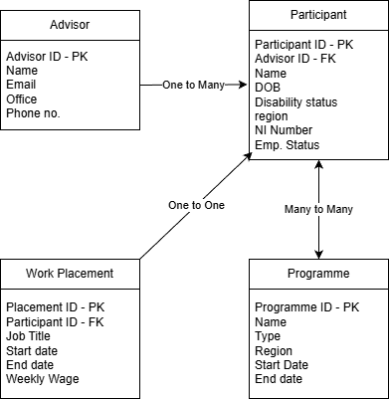

Key CRUD Functionality
- Add new participant
- Add new programme
- Create enrolment record
- Record job placement
- Update employment status
- Update completion status
- Record job end date
- Remove incorrect enrolment record
- Archive inactive programme
The initial ideas I have as to what this data could be used for are, what percentage of participants gain employment within three months, what is the average wage after placement, which demographics are least likely to find employment, How do outcomes vary by region?
Data Integrity and Security Considerations
To maintain data integrity within my system, I would include constraints such as, NOT NULL on fields such as Names, DOB’s, etc, UNIQUE on identifiers such as National Insurance number if stored and foreign key restraints to prevent orphaned records across records. I would also use CHECK to ensure things such as DOB being in the past, start dates being before end dates and wages being positive numbers.

